**Conservation of Mechanical Energy**

**Pre-lab questions**

1. What is the goal of this experiment? What physics and general science concepts does this activity demonstrate to the student?
2. What is the mathematical expression for gravitational potential energy?
3. Should the potential energy depend on the cart’s mass? Why, or why not?

The goal of the experiment is to investigate the idea that total mechanical energy remains constant in a closed, conservative system.

**Introduction:**

Beginning from Newton’s second law, the concepts of work and energy were introduced. From the **work-energy theorem** that resulted, work done by a force in displacing an object may become kinetic energy (energy of motion of the object) or potential energy (energy of the position of an object with respect to its system). **Kinetic energy** has the form $K=\frac{1}{2}mv^{2}$ for an object of mass *m* and speed *v*. **Potential energy** may take on a variety of different forms for different types of energy and physical situations. Most commonly for us, the form *U*grav = *mgh* describes the gravitational potential energy of an object with mass *m* at a height *h* relative to the Earth’s surface. As usual, *g* refers to the acceleration caused by Earth’s gravity near the Earth’s surface.

By the work-energy theorem, the sum of the kinetic and potential energies (known as the total mechanical energy) is constant when no other forces are performing net work on the system,

*E* = *K* + *U*. When this happens, *E* = *K* + *U = constant*, the system is called **conservative**.

Equipment:

Pasco Dynamics System with Smart gate, bracket, smart timer picket fence, rod and table clamp, rod and clamp, track elastic bumper, 2 end stops, meter stick, and balance scale.

Experiment

Beginning from the stationary cart, its initial kinetic energy is *K*0 = ½*mv*02 = 0 and its initial potential energy is *U*0 = *mgy*0. As the cart rolls freely downhill and its gravitational potential energy decreases, its value is given by $U_{1}=mgy_{1}$ where *y*1 is the new, lower vertical height of the cart. At the same time, the cart speeds up to *v*1 and its new kinetic energy is *K*1 = ½*mv*12.

The cart is released from the same height, multiple times, with the photogate measuring the speed at a different downhill location for each run. This allows values to be calculated for both potential and kinetic energy at various heights.

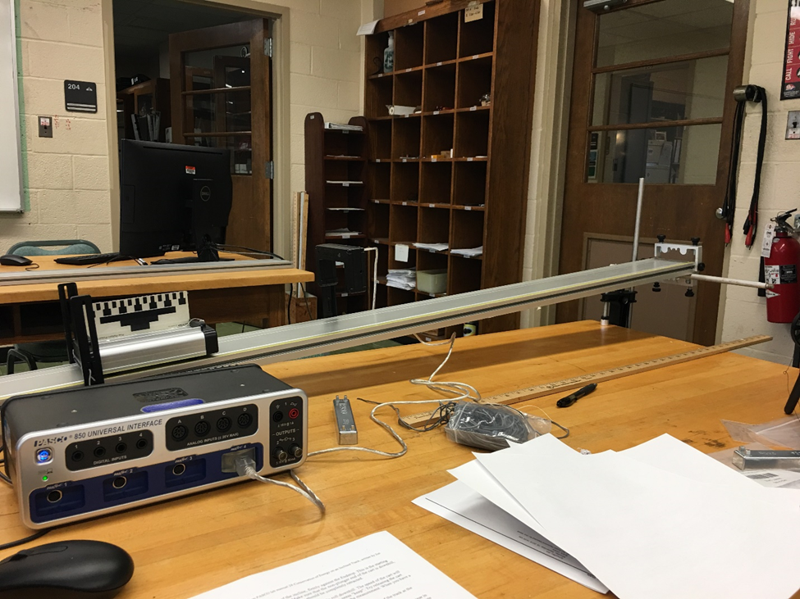

Figure 1: The cart rolls freely down the incline.

Setup:

1. Set up the track as shown in Figure 1. Use one of the Endstops to keep the track from sliding on the support rod.
2. Adjust the high end of the track to be about 15 cm to 20 cm above the table.
3. Note the location of the yellow rule on the track. Make sure that zero is at the top (left end) of the track.
4. The Endstop at the top (left end) of the track is used as a starting position for the cart. For each run, the cart will be released (at rest) from this same location.
5. Position the cart so that the non-plunger end is downhill. This end of the cart contains magnets, which must be kept as far as possible from the upper Endstop.
6. Plug the Smart gate into a PASPort input. The Smart gate will be placed at various locations to measure the speed of the cart as it rolls downhill.
7. In PASCO Capstone, in the Hardware Setup, the Smart gate shows up automatically. Click on the 2-1 yellow box of the Smart gate image. Select Smart gate [double Flag].
8. Change the data collection mode to Keep Mode on the Experiment Control Bar at the bottom of the page.
9. 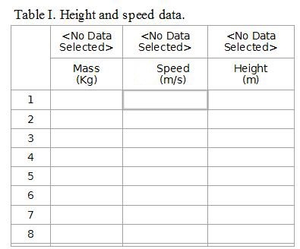Create a table as shown: Create Run-Tracked User-Entered data sets called “Mass” with units of kg and “Height” with units of m. The Speed in the second column is the speed recorded from the photogate.
10. Adjust the height of the Smart gate so that the "Double Flag" on the top of the Picket Fence breaks the beam as the cart moves by.
11. Install the Elastic Bumper at the bottom of the track. The Rubber Cord should be placed so that the cart pushes the cord into the slots, as shown in Figure 2. For safety, it is a good idea to use more than one piece of cord.
12. Each time that the Smart gate is moved to a new location, the new height must be measured. A convenient place to measure to is the bottom of the smart gate bracket (see Fig. 3). It doesn't matter where you measure to, but you must measure to the same place each time!
13. Make sure that the rod and clamp are secure. (You do not want the height of the track to change in the middle of the run!)
14. Make sure the endstop at the top of the track is secure. It is your starting position for the cart and it must be the same for each run.

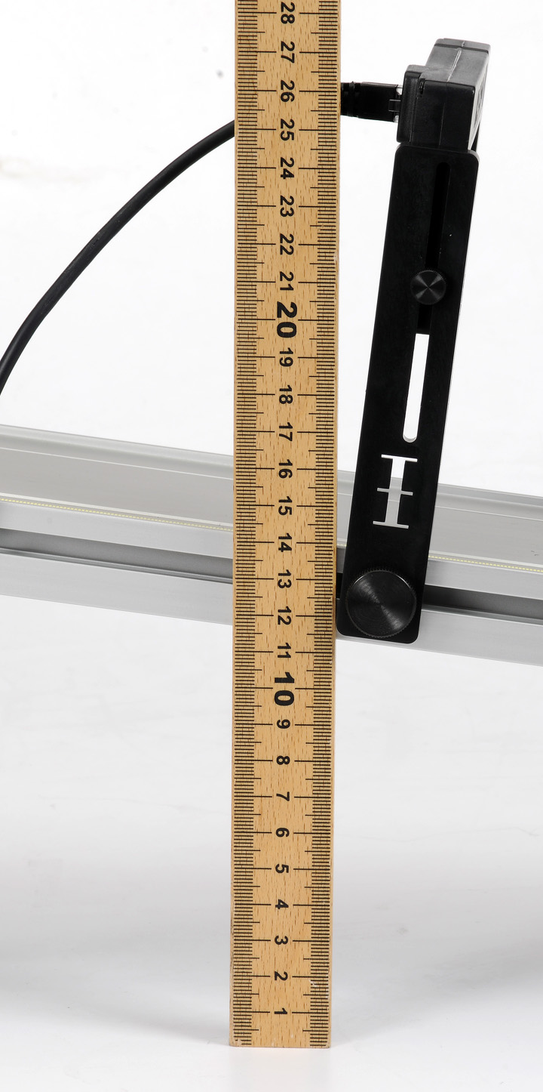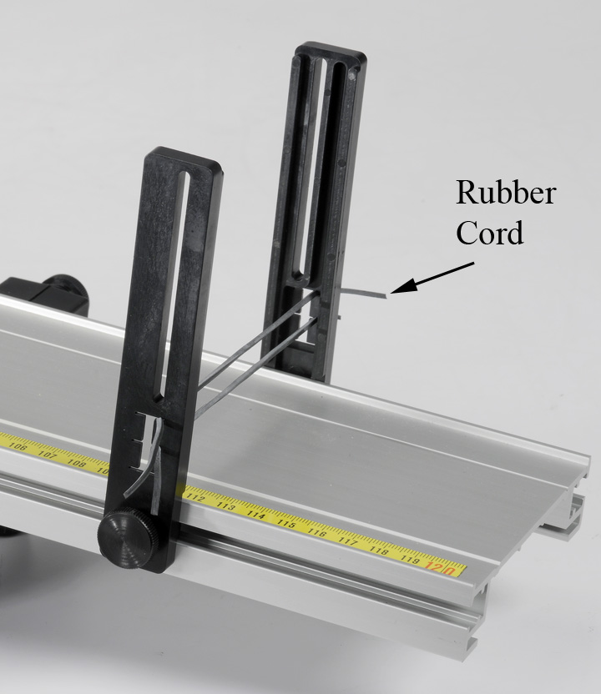

Figure 2: Elastic Bumper

Note that the Rubber Cord should be inserted into the bracket so that when it is hit by the cart, the cord is pushed into the slots. It is a good idea to use more than one piece of cord.

Measuring the height of the track at the Smart gate location. It doesn't matter where you measure to, but you must measure to the same place each time!

Figure 3: Smart gate Height

Procedure: Recording Data in "Keep Mode"

1. To start recording data, click on Preview in the Experiment Control Bar. Run 1 should appear at the top of each column in Table I. Columns 1 and 3 are user entered data (see below) and column 2 is for the measured speed of the cart. The program is set for "Keep Mode", and the speed value for each part will not be stored until you click on "Keep Sample"
2. Use a balance to measure the mass of the "Cart + Picket Fence". Enter the value in column 1. For this part of the experiment, the mass does not change, but the value will need to be entered for each row of data you take.
3. Position the Smart gate near the upper end of the track at the 20 cm mark. It doesn't matter if you line up the mark with the left side or right side of the bracket, but you should do it the same way each time you move the photogate. Measure the height of the track at the Smart gate location, and record your value in row 1 of column 3.
4. As a test, move the cart (by hand) through the Smart gate. You should see a speed appear in row one of column 2. Move the cart back and forth through the Smart gate. You should see a new measured speed each time.
5. Position the cart at the top of the incline, firmly against the Endstop. This is the starting position for the cart each time. Make sure that the non-plunger end of the cart is downhill, away from the Endstop. The plunger should be completely retracted.
6. Release the cart from rest, allowing it to freely roll downhill. The speed of the cart will appear in the table, but will not be stored until you press "keep". Try releasing the cart several times to see how much uncertainty there is in the measurement. When you have a good value, click on "Keep Sample". Do NOT press stop!
7. Position the Smart gate at the 30 cm mark, and measure the height of the track at the Smart gate, and record your value in row 2 of the table.
8. Release the cart from rest at the top of the incline. You should see the speed appear in row two. When you have a good value, click on "Keep Sample". Repeat for Smart gate positions of 40, 50, 60 70 and 80 cm. Do not let the cart bounce back up through the Smart gate.
9. Click on Stop.

Calculating Energy

1. Create the following calculations (Fig. 4) in the Capstone calculator (all with units of J). Remember typing [ will bring up user entered data columns, equations and constants.

Potential Energy ‎= [mass (kg)‎] [height (m)‎]*9.8

‎ Kinetic Energy‎ = 0.5[mass (kg)‎] [Speed (m/s)‎]^2

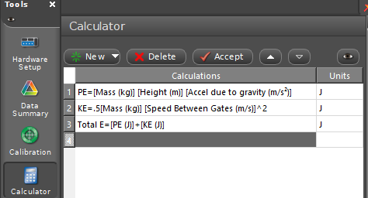Total Energy ‎= [Potential Energy (J)‎] + [Kinetic Energy (J)‎]

Figure 4: Capstone energy calculation

1. 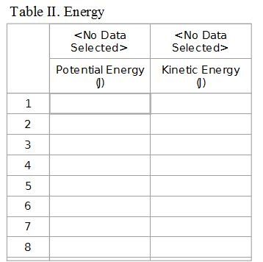Create a table with the Potential Energy and Kinetic Energy.
2. For one of the data sets in Table I, calculate the potential energy and kinetic energy of the cart for that height. Confirm that the corresponding value is correct in Table II.
3. Create a graph of Potential Energy vs. Index. Use Add Similar Measurement (left click on P.E on y-axis) to add Kinetic Energy and Total Energy to the vertical axis.
4. What happens to the relative value of the potential energy and kinetic energy as the cart rolls down the hill?
5. Evaluate the total energy of the cart. Is energy conserved?

Change Mass:

1. To start recording a new run of data, click on Preview in the Experiment Control Bar. Run 2 should appear at the top of each column in Table I.
2. Add the Mass Bar to the cart and measure the new mass. Enter the value in column 1.
3. Move the Photogate back up to the 20 cm mark. Start with the cart at rest against the stop, and allow the cart to roll through the Photogate as before. When you have a good value, click on "Keep Sample". Do NOT press stop!
4. Repeat for the other five locations.
5. Click on Stop.

Change Angle

1. To start recording a new run of data, click on Preview in the Experiment Control Bar. Run 3 should appear at the top of each column in Table I.
2. Change the height of the end of the track by a few centimeters. Move the Photogate back up to the 20 cm mark and measure the new height. If the old height values are in the table, you can delete them. Record the new value.
3. Measure height and speed values for all locations.
4. Click on Stop.

Analysis

1. Use the Run Select Tool () in the Graph Tool Bar to compare the three runs. (*Left click once to highlight, then click on the down triangle. This will allow you to select multiple runs rather than just switch between them.*) Is energy conserved?
2. What effect would friction have on the experiment? Do you see this in your data?
3. When you increased the mass of the cart, how did this affect the Potential Energy of the cart at any given location? How did this affect the Kinetic Energy of the cart? How did this affect the speed of the cart? In Table I, compare the speeds for Run 1 to the speeds for Run 2. Is that what you expected?
4. The height used to calculate the Potential Energy was measured to an arbitrary point on the track. What would change in the experiment if you had chosen a different point?